SHANGHAI FREEMEN CHEMICALS CO.,LTD.
ADDRESS: SUITES 22G, SHANGHAI INDUSTRIAL INVESTMENT
BLDG.,18 CAOXI RD.(N),SHANGHAI 200030,CHINA
TEL:021-64279170 Emai: ni.xiaohu@freemen.sh.cn

Product: 2,6-Diethylaniline
2,6-Diethylaniline, a clear liquid, is an intermediate for the production of alachlor, butachlor, metolachlor-herbicides, tiafentiurone-insecticide, carbodiimide and RIM-PUR.
Alias: 2-Amino-1,3-diethylbenzene; 2,6-diethyl-benzenamin; 2,6 DEA

CAS No: 579-66-8
Molecule structure 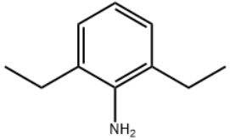

Specifications:
Appearance: Clear liquid
Purity: 99.0%min
Water: 0.2%max
Aniline: 0.3%max
Packing & Delivery 22mt/ISO tank
Not dangerous goods
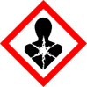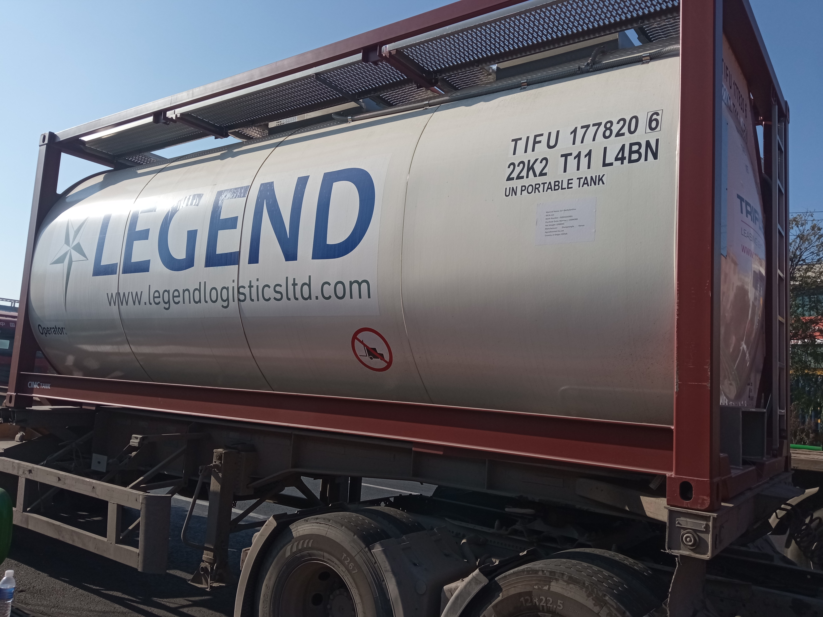

Application an intermediate for the production of alachlor, butachlor, metolachlor-herbicides, tiafentiurone-insecticide, carbodiimide and RIM-PUR.
be used as a reagent in the synthesis of herbicides, for instance Butachlor (B689925); a pre-emergent chloroacetanalide herbicide commonly used for weed control in rice as well as cotton, maize, wheat and other crops.

